|  |
| --- |
| Department of Computer & Software Engineering  **Bahria University Karachi Campus**  13 National Stadium Road |

|  |
| --- |
| Database Management System |
| SM MANAGEMENT SYSTEM |
| |  |  | | --- | --- | | **Submitted To** | **Engr. Bushra Fazal / Engr. Saniya Sarim** | | **Students** |  | | Uzair Mehmood | 51739 | | Mohsin Ali | 51751 | | Muhammad Asad | 51723 | | Noman Ali Siddique | 51777 | |

**Table of Contents**

01 Introduction 2

02 Goal 2

03 Existing System 3

04 Proposed Solution 3

05 Work Flow Diagram 4

06 Entity-Relationship Diagram 5

07 Database Queries 5

07.1 Queries 5

07.2 Stored Procedures 7

08 GUI Specification 17

09 Conclusion 25

10 References: 25

# Introduction

The computer has brought revolution in every sphere of human life. Whether It is business, education field, governance, medical science etc. The computer has reduced the human work load, business is going global and every thing is available at the click of mouse. The concept of e-shopping has been introduced and we can buy the products online and make payments through credit or debit cards.

Presently I am proposing a system “SM Management System”. The Super Market issue their client’s handwritten bills and they enter details in manual registers. And maintain bills and they enter details in manual registers. And maintain MS Excel File for product rate. So the proposed system will computerized their manual bill generation system.

As stated above the general stores presently uses manual bills and hand written record to maintains their product list, customer list, and keep the invoice, there is lot of duplicate work, and chance of mistake. When the product prices are changed, they need to update each and every hand written record.

There is no security; anybody can access any report and sensitive data, also there are no reports to find out the sales volume, stock list, and summary report. This Billing system is used to overcome the entire problem which the client is facing currently, and making complete atomization of manual billing system.

# Goal

* **Admin and User Login:** Separate login for user and admin. Limiting the access of user in this Software.
* **Forgot Password:** Admin and user can reset their password.
* **Manage Users:** Admin can add, update and delete users (using software).
* **Manage Employees:** Admin can add, update and delete employees (working in store).
* **Manage Drivers:** Admin can add, update and delete driver.
* **Manage Suppliers:** Admin can add, update and delete supplier.
* **Manage Products:** Admin can add, update and delete products.
* **Manage Vehicles:** Admin can add, update and delete vehicles used in home deliveries.
* **Place Order:** Admin and user both can place user order.
* **Manage Orders:** Admin and user both can add, update and delete orders placed.
* **Manage Home Deliveries:** Admin and user both can add, update and delete home deliveries for orders placed.
* **Receipt:** Receipt is generated for every order placed.

# Existing System

Presently the existing system of the SM Management System *MUNA* use manually prepared and some MS-Excel database for the purchase and present available stocks record. The manually preparation of data on the register is really tedious and error prone (tending to make or cause error).

**Problems Faced by the Current System**

* Information is stored in written form in register and some MS-Excel. This has many disadvantages. Checking a record in a register takes more time.
* Registers require more space.
* There is no space for proper management stocks in store.
* Retrieving information from registers is more difficult and error prone.
* It is difficult to find and modify existing records.
* Current system being manual is more error prone.

# Proposed Solution

Main objective of the project is

* To integrate the various General store information at one place.
* To reduce the paperwork involved to be minimum.
* To generate invoice for every customer data wise. To generate bill date to date wise.

# Work Flow Diagram



# Entity-Relationship Diagram

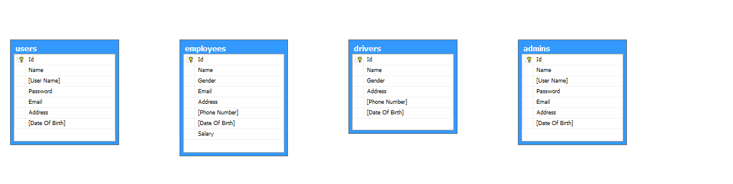

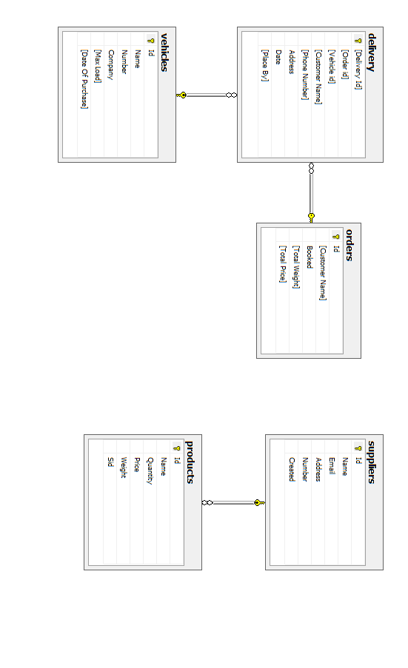

# Database Queries

## Queries

**Admin:**

create table admins

(

Id int NOT NULL Identity,

Name varchar(50) NOT NULL,

primary key(Id),

[User Name] varchar(50) NOT NULL unique,

Password varchar(50) NOT NULL,

Email varchar(50) NOT NULL unique,

Address varchar(250) NOT NULL,

[Date Of Birth] Date Not NULL,

);

**User:**

create table users

(

Id int NOT NULL Identity,

Name varchar(50) NOT NULL,

primary key(Id),

[User Name] varchar(50) NOT NULL unique,

Password varchar(50) NOT NULL,

Email varchar(50) NOT NULL unique,

Address varchar(250) Not Null,

[Date Of Birth] Date Not NULL,

);

**Employee:**

create table employees

(

Id int primary key identity,

Name varchar(50) NOT NULL,

Gender varchar(10) Not Null,

Email varchar(50) NOT NULL unique,

Address varchar(250) NOT NULL,

[Phone Number] varchar(20) NOT NULL unique,

[Date Of Birth] Date Not NULL,

Salary int not null

)

**Supplier:**

create table suppliers

(

Id int primary key identity,

Name varchar(50) NOT NULL unique,

Email varchar(50) Not null unique,

Address varchar(250) NOT NULL,

Number varchar(20) Not Null unique,

Created Date Not Null,

)

**Product:**

create table products

(

Id int identity,

Name varchar(50) NOT NULL unique,

Quantity int Not null,

Price int NOT NULL,

Weight int not null,

Sid int NOT NULL,

Primary Key (Id),

Foreign Key (Sid) References suppliers(Id)

)

**Order:**

create table orders

(

Id int primary key identity,

[Customer Name] varchar(50),

Booked Date not null,

[Total Weight] int not null,

[Total Price] int not null,

)

**Delivery:**

create table delivery

(

[Delivery Id] int primary key identity,---------------------------------------

[Order id] int not null,

[Vehicle id] int not null,-----------------------------------------------------

[Customer Name] varchar(50) not null,

[Phone Number] varchar(20) not null,--------------------------------------------

Address varchar(250) not null,------------------------------------------------------

Date Date not null,

[Place By] varchar(50),

Foreign key ([Order Id]) References orders(Id),

Foreign key ([Vehicle Id]) References vehicles(Id),

)

**Driver:**

create table drivers

(

Id int primary key identity,

Name varchar(50) NOT NULL,

Gender varchar(10) not null,

Address varchar(250) NOT NULL,

[Phone Number] varchar(20) NOT NULL unique,

[Date Of Birth] Date Not NULL,

)

**Vehicle:**

create table vehicles

(

Id int primary key identity,

Name varchar(50) NOT NULL,

Number varchar(20) Not null unique,

Company varchar(50) not null,

[Max Load] int not null,

[Date Of Purchase] Date not null,

)

## Stored Procedures

**Admin:**

-----------------Show admin

create procedure pro_show_admins

AS

Select * from admins

--

exec pro_show_admins

----------------Delete Admin

create proc pro_delete_admins

@Id int

AS

delete from admins where Id=@Id

Go

--

exec pro_delete_admins 2

----------------Insert Admin

create proc pro_insert_admins

@Name varchar(50),@UserName varchar(50),@Password varchar(50),@Email varchar(50),@Address varchar(250),@DateOfBirth Date

AS

insert into admins values (@Name,@UserName,@Password,@Email,@Address,@DateOfBirth)

Go

--

exec pro_insert_admins 'Uzair Mehmood','iamuzairmehmood','0111','uzairmehmood480@gmail.com','House # 17 Street # 09 Sector # 04 Naval Colony Hub River Road Karachi','1998-10-28'

----------------update Admin

create proc pro_update_admins

@Id int, @Name varchar(50),@UserName varchar(50),@Password varchar(50),@Email varchar(50),@Address varchar(250),@DateOfBirth Date

AS

update admins set Name = @Name ,[User Name] = @UserName, Password = @Password, Email = @Email, Address = @Address ,[Date Of Birth]= @DateOfBirth where Id = @Id

Go

--

exec pro_update_admins 1,'Uzair Mehmood','iamuzairmehmood','0111','uzairmehmood480@gmail.com','House # 17 Street # 09 Sector # 04 Naval Colony Hub River Road Karachi','1998-10-28'

----------------Search Admin

create proc pro_search_admins

@Name varchar(50)

As

Select * from admins where Name Like '%'+@Name+'%'

Go

exec pro_search_admins 'Uza'

---------------Admin Login

create proc pro_login_admins

@UserName varchar(50),@Password varchar(50)

As

Select count(*) from admins where [User Name] = @UserName And Password = @Password

Go

**User:**

--------------Show users

create procedure pro_show_users

AS

Select * from users

--

exec pro_show_users

----------------Delete Users

create proc pro_delete_users

@Id int

AS

delete from users where Id=@Id

Go

--

exec pro_delete_users 2

----------------Insert Users

create proc pro_insert_users

@Name varchar(50),@UserName varchar(50),@Password varchar(50),@Email varchar(50),@Address varchar(250),@DateOfBirth Date

AS

insert into users values (@Name,@UserName,@Password,@Email,@Address,@DateOfBirth)

Go

--

exec pro_insert_users 'Uzair Mehmood','iamuzairmehmood','0111','uzairmehmood480@gmail.com','House # 17 Street # 09 Sector # 04 Naval Colony Hub River Road Karachi','1998-10-28'

----------------update Users

create proc pro_update_users

@Id int, @Name varchar(50),@UserName varchar(50),@Password varchar(50),@Email varchar(50),@Address varchar(250),@DateOfBirth Date

AS

update users set Name = @Name ,[User Name] = @UserName, Password = @Password, Email = @Email, Address = @Address ,[Date Of Birth]= @DateOfBirth where Id = @Id

Go

--

exec pro_update_users 1,'Uzair Mehmood','iamuzairmehmood','0111','uzairmehmood480@gmail.com','House # 17 Street # 09 Sector # 04 Naval Colony Hub River Road Karachi Pakistan','1998-10-28'

----------------Search Users

create proc pro_search_users

@Name varchar(50)

As

Select * from users where Name Like '%'+@Name+'%'

Go

exec pro_search_users 'Uza'

---------------User Login

create proc pro_login_users

@UserName varchar(50),@Password varchar(50)

As

Select count(*) from admins where [User Name] = @UserName And Password = @Password

Go

**Employee:**

-----inserting data

insert into employees values ('Uzair Mehmood','Male','uzairmehmood480@gmail.com','House # 17 Street # 09 Sector # 04 Naval Colony Hub River Road Karachi','+923110240059','1998-10-28',456987)

-------------------------------------------------------------- Procedures ----------------------------------------------------

-----------------Show Employees

create procedure pro_show_employees

AS

Select * from employees

Go

--

exec pro_show_employees

----------------Delete Employees

create proc pro_delete_employees

@Id int

AS

delete from employees where Id=@Id

Go

--

exec pro_delete_employees 1

----------------Insert Employees

create proc pro_insert_employees

@Name varchar(50),@Gender varchar(10),@Email varchar(50),@Address varchar(250),@Phonenumber varchar(20),@DateOfBirth Date,@Salary int

AS

insert into employees values (@Name,@Gender,@Email,@Address,@Phonenumber,@DateOfBirth,@Salary)

Go

--

exec pro_insert_employees 'Uzair Mehmood','Male','uzairmehmood480@gmail.com','House # 17 Street # 09 Sector # 04 Naval Colony Hub River Road Karachi','+923110240059','1998-10-28',456987

----------------Update Employees

create proc pro_update_employees

@Id int,@Name varchar(50),@Gender varchar(10),@Email varchar(50),@Address varchar(250),@Phonenumber varchar(20),@DateOfBirth Date,@Salary int

AS

update employees set Name = @Name ,Gender= @Gender,Email = @Email, Address = @Address, [Phone Number] =@Phonenumber ,[Date Of Birth]= @DateOfBirth,Salary = @Salary where Id = @Id

Go

--

exec pro_update_employees 1,'Uzair Mehmood','Male','uzairmehmood480@gmail.com','House # 17 Street # 09 Sector # 04 Naval Colony Hub River Road Karachi','+923110240059','1998-10-28',4569898

----------------Search Emloyees

create proc pro_search_employees

@Name varchar(50)

As

Select * from employees where Name Like '%'+@Name+'%'

Go

--

EXEC pro_search_employees Uza

**Supplier:**

-----inserting data

insert into suppliers values ('Blk','blk@mail.com','Isla h 13 floor 4','0325567897','1998-07-28')

insert into suppliers values ('Baksd','bsdlk@mail.com','Islaasdads h 1332 house ds32 floor 4','0142567897','1992-10-13')

-------------------------------------------------------------- Procedures ----------------------------------------------------

-----------------Show Suppliers

create procedure pro_show_suppliers

AS

Select * from suppliers

Go

--

exec pro_show_suppliers

----------------Delete Suppliers

create proc pro_delete_suppliers

@Id int

AS

delete from suppliers where Id=@Id

Go

--

exec pro_delete_suppliers 2

----------------Insert Suppliers

create proc pro_insert_suppliers

@Name varchar(50),@Email varchar(50),@Address varchar(50),@Number varchar(20),@Created Date

AS

insert into suppliers values (@Name,@Email,@Address,@Number,@Created)

Go

--

exec pro_insert_suppliers

----------------Update Suppliers

create proc pro_update_suppliers

@Id int,@Name varchar(50),@Email varchar(50),@Address varchar(50),@Number varchar(20),@Created Date

AS

update suppliers set Name = @Name, Email = @Email,Address=@Address,Number=@Number,Created=@Created where Id=@Id

Go

--

exec pro_update_suppliers

----------------Search Suppliers

create proc pro_search_suppliers

@Name varchar(50)

As

Select * from suppliers where Name Like '%'+@Name+'%'

Go

--

EXEC pro_search_suppliers b

**Product:**

------------------------------------------------------- Procedures ----------------------------------------------------

-----------------Show Products

create procedure pro_show_products

AS

Select * from products

Go

--

exec pro_show_products

----------------Delete Products

create proc pro_delete_products

@Id int

AS

delete from products where Id=@Id

Go

--

exec pro_delete_products 2

----------------Insert Products

create proc pro_insert_products

@Name varchar(50),@Quantity int,@Price int,@Weight int,@Sid int

AS

insert into products values (@Name,@Quantity,@Price,@Weight,@Sid)

Go

--

exec pro_insert_products

----------------Update Products

create proc pro_update_products

@Id int,@Name varchar(50),@Quantity int,@Price varchar(250),@Weight int,@Sid int

AS

update products set Name = @Name, Quantity=@Quantity,Price=@Price,Weight = @Weight,Sid=@Sid where Id=@Id

Go

--

exec pro_update_products

----------------Search Products

create proc pro_search_products

@Name varchar(50)

As

Select * from products where Name Like '%'+@Name+'%'

Go

--

EXEC pro_search_products

----------------Increment Quantity

create procedure pro_decquantity_products

@Id int, @Quantity int

as

begin

Update products SET Quantity = Quantity - @Quantity where Id = @Id;

end

go

exec Pro_decquantity_products

----------------Decrement Quantity

create procedure pro_incquantity_products

@Id int, @Quantity int

as

begin

Update products SET Quantity = Quantity + @Quantity where Id = @Id;

end

go

**Order:**

-----------------Show Orders

create procedure pro_show_orders

AS

Select * from orders

Go

--

exec pro_show_orders

----------------Delete Orders

create proc pro_delete_orders

@Id int

AS

delete from orders where Id=@Id

Go

--

exec pro_delete_orders

----------------Insert Orders

create proc pro_insert_orders

@CustomerName varchar(50),@Booked Date,@TotalWeight int,@TotalPrice int

AS

insert into orders values (@CustomerName,@Booked,@TotalWeight,@TotalPrice)

Go

--

exec pro_insert_orders

----------------Update Orders

create proc pro_update_Orders

@Id int,@CustomerName varchar(50),@Booked Date,@TotalWeight int,@TotalPrice int

AS

update orders set [Customer Name]= @CustomerName,Booked=@Booked,[Total Weight]=@TotalWeight,[Total Price]=@TotalPrice where Id=@Id

Go

--

exec pro_update_Orders

----------------Search Orders

create proc pro_search_orders

@Name varchar(50)

As

Select * from orders where [Customer Name] Like '%'+@Name+'%'

Go

--

EXEC pro_search_orders

**Delivery:**

-----inserting data

insert into delivery values ()

-------------------------------------------------------------- Procedures ----------------------------------------------------

-----------------Show Delivery

create procedure pro_show_delivery

AS

Select * from delivery

Go

--

exec pro_show_delivery

----------------Delete Delivery

create proc pro_delete_delivery

@Id int

AS

delete from delivery where Id=@Id

Go

--

exec pro_delete_delivery 1

----------------Insert Delivery

create proc pro_insert_delivery

@Orderid int,@Vehicleid int,@CustomerName varchar(50),@PhoneNumber varchar(20),@Address varchar(250),@Date Date,@placeby varchar(50)

AS

insert into delivery values (@Orderid,@Vehicleid,@CustomerName,@PhoneNumber,@Address,@Date,@placeby)

Go

--

exec pro_insert_delivery

----------------Update Delivery

create proc pro_update_delivery

@Id int,@PhoneNumber varchar(20),@Address varchar(250)

AS

update delivery set [Phone Number]=@PhoneNumber,[Address]=@Address where [Delivery Id]=@Id

Go

--

exec pro_update_delivery

----------------Search delivery

create proc pro_search_delivery

@CustomerName varchar(50)

As

Select * from delivery where [Customer Name] Like '%'+@CustomerName+'%'

Go

--

EXEC pro_search_delivery

**Driver:**

-----inserting data

insert into drivers values ('Uzair Mehmood','Male','House # 17 Street # 09 Sector # 04 Naval Colony Hub River Road Karachi','03110240059','1998-10-28')

-------------------------------------------------------------- Procedures ----------------------------------------------------

-----------------Show Drivers

create procedure pro_show_drivers

AS

Select * from drivers

Go

--

exec pro_show_drivers

----------------Delete Drivers

create proc pro_delete_drivers

@Id int

AS

delete from drivers where Id=@Id

Go

--

exec pro_delete_drivers 2

----------------Insert Drivers

create proc pro_insert_drivers

@Name varchar(50),@Gender varchar(10),@Address varchar(250),@Phonenumber varchar(20),@DateOfBirth Date

AS

insert into drivers values (@Name,@Gender,@Address,@Phonenumber,@DateOfBirth)

Go

--

exec pro_insert_drivers 'Uzair Mehmood','Male','House # 17 Street # 09 Sector # 04 Naval Colony Hub River Road Karachi','03110240059','1998-10-28'

----------------Update Drivers

create proc pro_update_drivers

@Id int,@Name varchar(50),@Gender varchar(10),@Address varchar(250),@Phonenumber varchar(20),@DateOfBirth Date

AS

update drivers set Name = @Name ,Gender = @Gender, Address = @Address, [Phone Number] =@Phonenumber ,[Date Of Birth]= @DateOfBirth where Id=@Id

Go

--

exec pro_update_drivers 1,'Uzair Mehmood','Male','House # 17 Street # 09 Sector # 04 Naval Colony Hub River Road Karachi Pakistan','03110240059','1998-10-28'

----------------Search Drivers

create proc pro_search_drivers

@Name varchar(50)

As

Select * from drivers where Name Like '%'+@Name+'%'

Go

--

EXEC pro_search_drivers Uza

**Vehicle:**

-----inserting data

insert into vehicles values ()

-------------------------------------------------------------- Procedures ----------------------------------------------------

-----------------Show Vehicles

create procedure pro_show_vehicles

AS

Select * from vehicles

Go

--

exec pro_show_vehicles

----------------Delete Vehicles

create proc pro_delete_vehicles

@Id int

AS

delete from vehicles where Id=@Id

Go

--

exec pro_delete_vehicles 2

----------------Insert vehicles

create proc pro_insert_vehicles

@Name varchar(50),@Number varchar(20),@Company varchar(50),@MaxLoad int,@DateOfPurchase Date

AS

insert into vehicles values (@Name,@Number,@Company,@MaxLoad,@DateOfPurchase)

Go

--

exec pro_insert_vehicles

----------------Update Vehicles

create proc pro_update_vehicles

@Id int,@Name varchar(50),@Number varchar(20),@Company varchar(50),@MaxLoad int,@DateOfPurchase Date

AS

update vehicles set Name = @Name,Number = @Number,Company = @Company, [Max Load] = @MaxLoad,[Date Of Purchase] = @DateOfPurchase where Id=@Id

Go

--

exec pro_update_vehicles

----------------Search vehicles

create proc pro_search_vehicles

@Name varchar(50)

As

Select * from vehicles where Name Like '%'+@Name+'%'

Go

--

EXEC pro_search_vehicles

# GUI Specification

Starting form

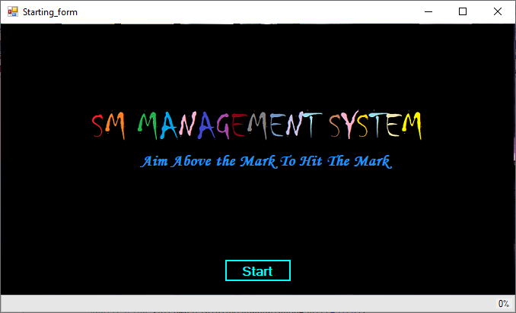

Login

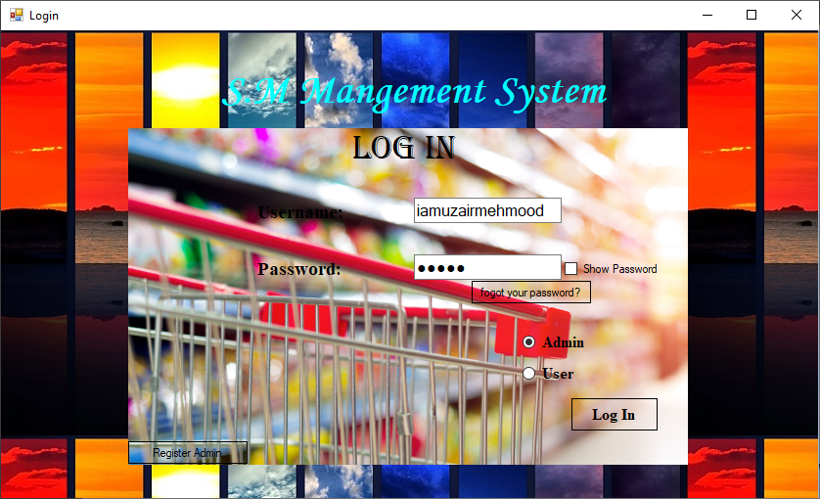

Admin Panel

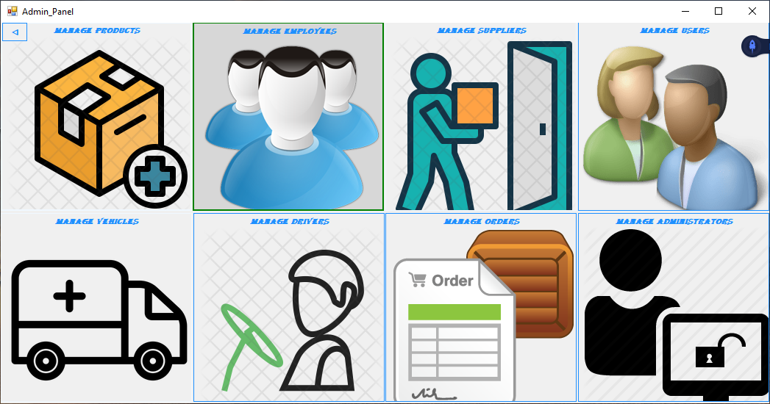

User Panel

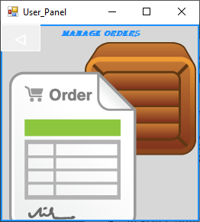

Register Admin

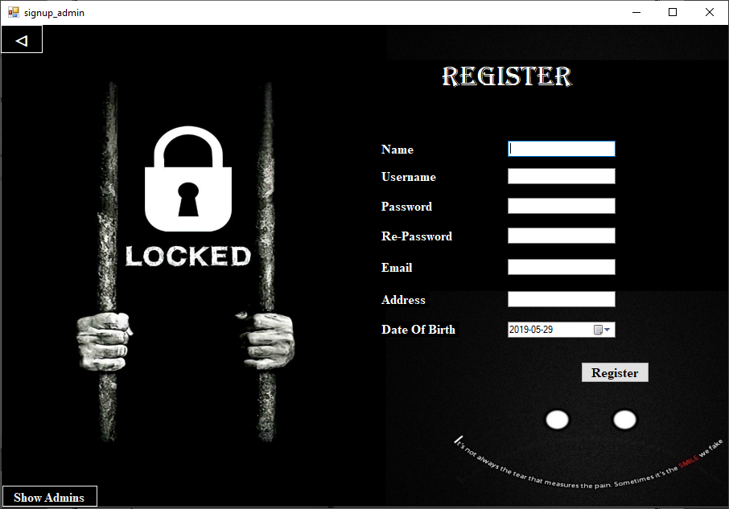

Manage Admins

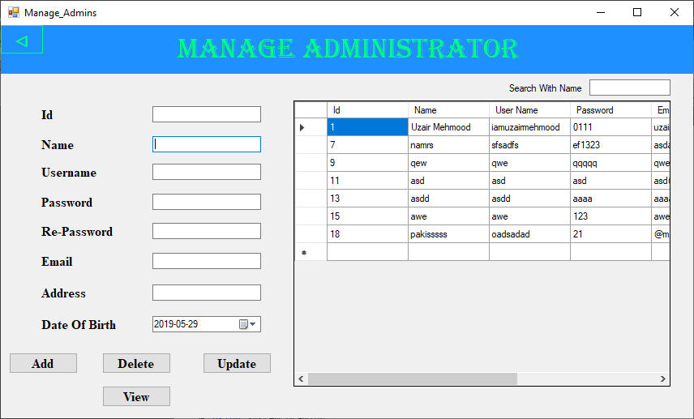

Manage User

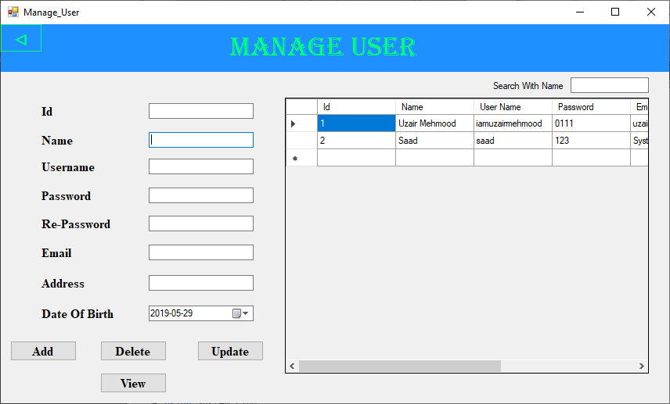

Manage Employee

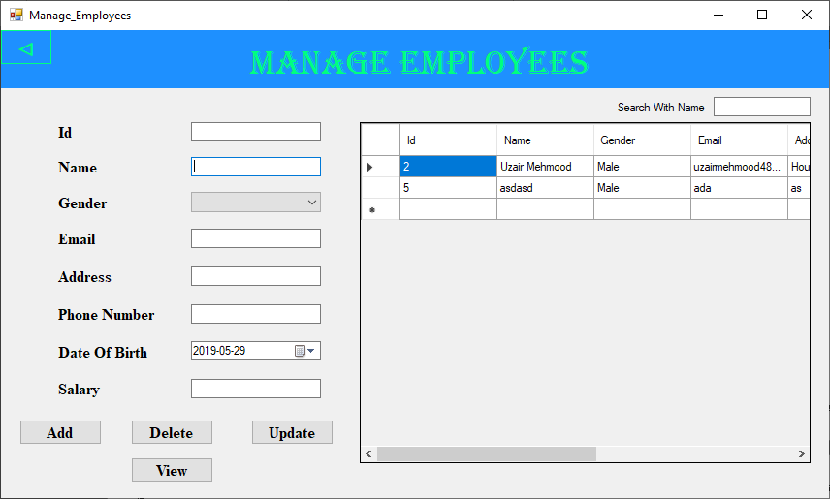

Manage Suppliers

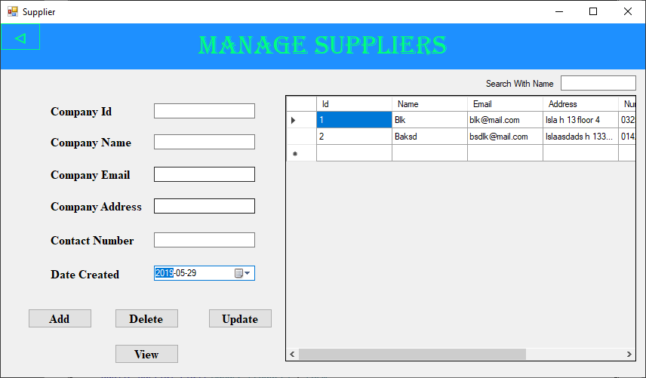

Manage Products

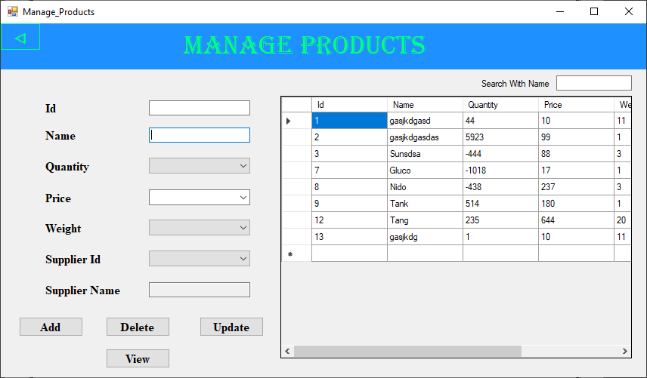

Manage Drivers

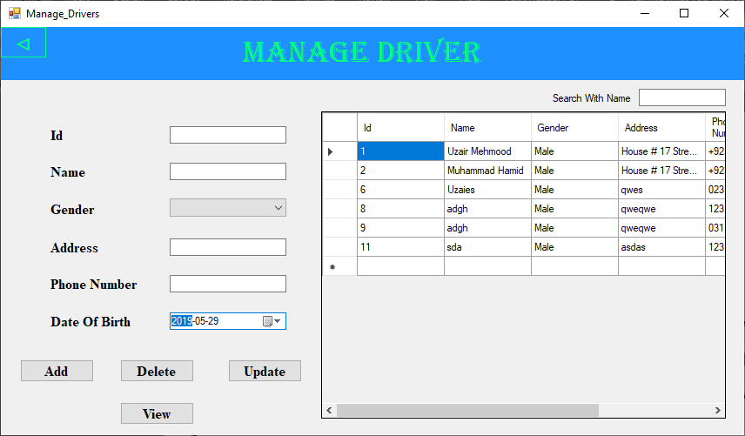

Manage Vehicle

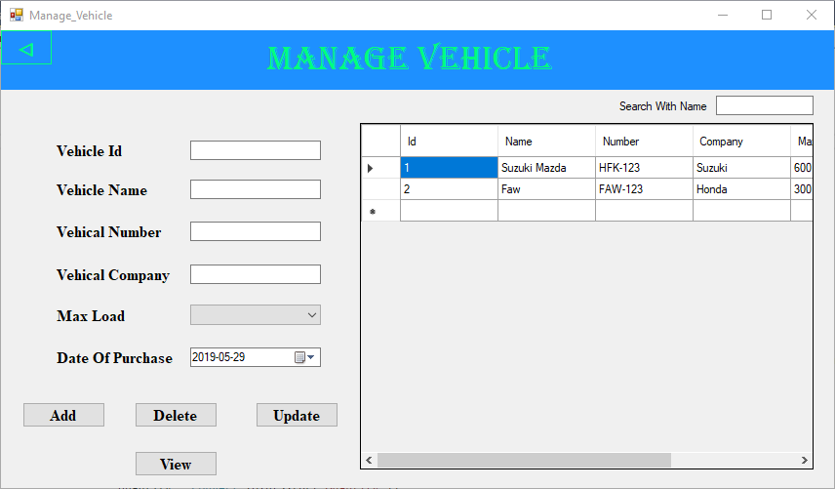

Show Admins

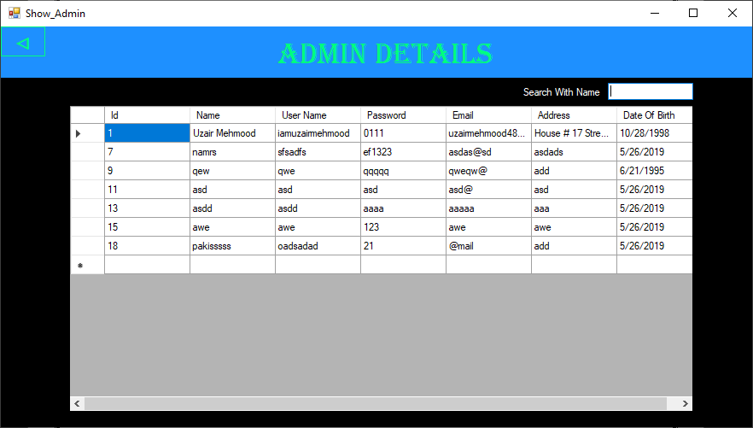

Orders

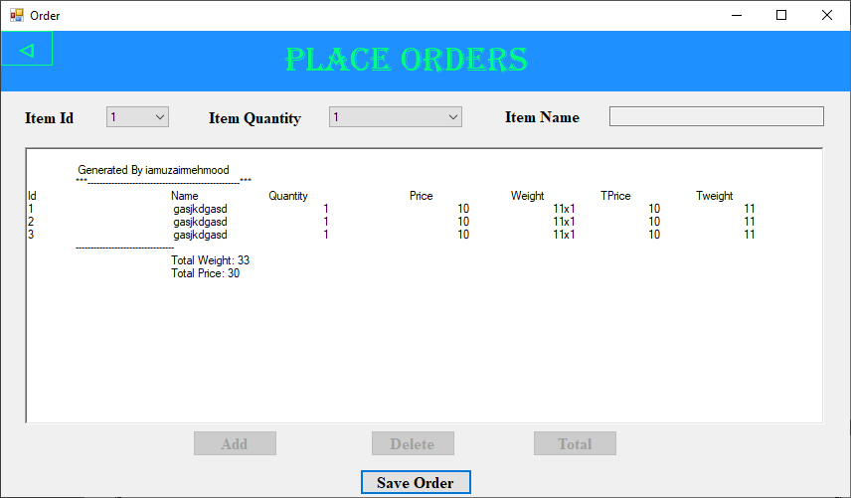

Book Order

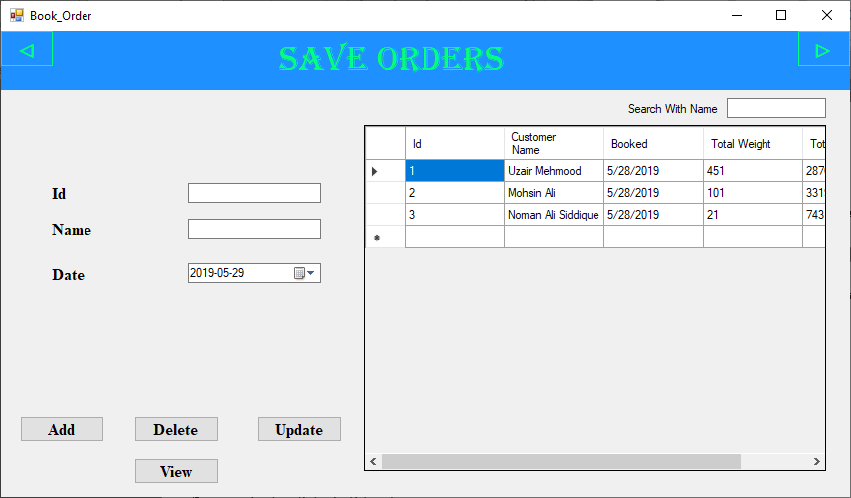

Home Delivery

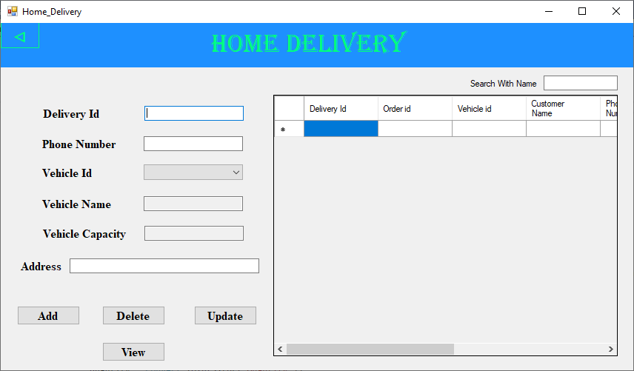

# Conclusion

This software provides an easy way for the operator to interact with the database and to manipulate the data in the database.

The operator can add delete and update records in the database with ease.

# References:

* Wikipedia.org
* SlideShare.net
* Scribd.com
* gnousupport.blogspot.com
* lucidchart.com
* sites.google.com site/ignoubcafinalyearprojects/home
* East West University
* Smartdraw
* coursehero